

NAME: EXCELLENCE NG’ENDO
ADM NO: BSCCS/2024/53679

COURSE: BACHELOR OF SCIENCE IN COMPUTER SCIENCE
DEPARTMENT: COMPUTING AND INFORMATICS.
UNIT NAME: ADVANCED WEB DESIGN AND DEVELOPMENT
UNIT CODE:BIT3208
Lecturer Name- MICHAEL NYORO
Academic Year -3.2
Project Title: Decorum Bookshop Inventory System
Selected Technologies - PHP + MYSQL

GitHub Link: https://github.com/ExcellenceCreates05/DecorumBookshop-Inventory-System

Table of Contents
TABLE OF FIGURES 3
Week 1: Local Environment Setup 4
Installation and Testing of Local Development Environment 4
Week 2: Wireframes and GUI Design 7
Title: User Interface Planning and System Design 7
REFLECTION
Week 3: JavaScript and PHP Basics 11
Title:Frontend Interaction and Backend Foundation 11
REFLECTION 14
Week 4 Lesson: Server-Side Components and Backend Development Foundations 15
REFLECTION 18
WEEK 5 19
TOPIC: Database Components and CRUD Operations 19
REFLECTION 24

TABLE OF FIGURES
Figure 0-1:Installation of XAMPP 5
Figure 0-2: Apache and MySQL Running 5
Figure 0-1:Localhost Test Page 6
Figure 0-2: Hello World Test 6
Figure 0-3: Database Connection Test 6
Figure 0-4: Error experienced during connection test. 7
Figure 0-5:PHP script for creating decorum_bookshop 7
Figure 0-1: Admin Product View 8
Figure 0-2:Admin Dashboard 8
Figure 0-3:Users Order View 9
Figure 0-1:JavaScript Form Validation 10
Figure 0-2:Email & Password validation. 11
Figure 0-3:Password checker code 11
Figure 0-4:Successful login 12
Figure 0-5:Successful Database Connection 12
Figure 0-6: Successful login Into Decorum Bookshop 13
Figure 0-7: Hidden Sidebar 13

Week 1: Local Environment Setup

Installation and Testing of Local Development Environment
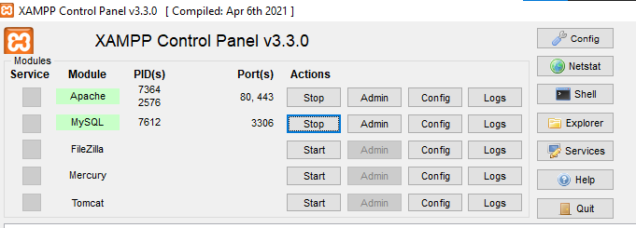
Figure 0-1:Installation of XAMPP

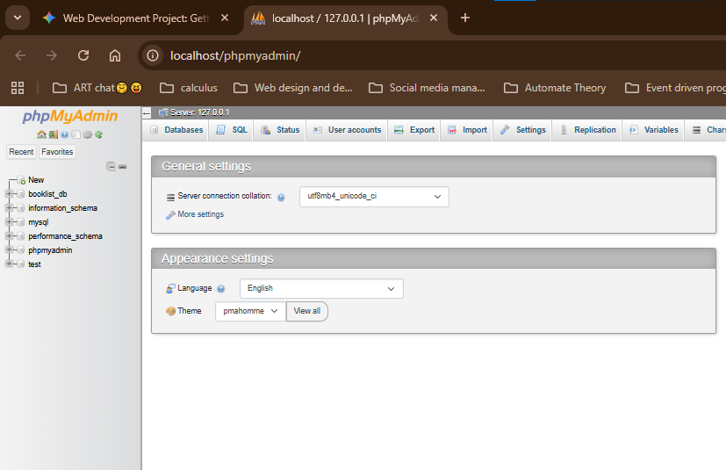
Figure 0-2: Apache and MySQL Running

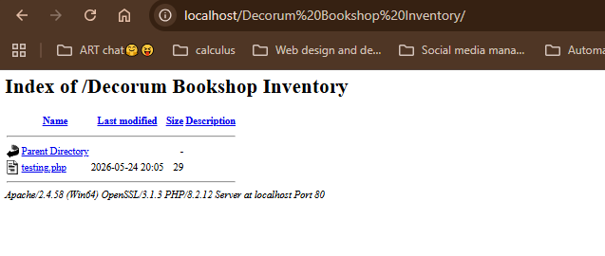
Figure 0-1:Localhost Test Page
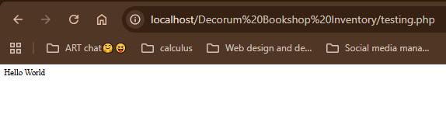
Figure 0-2: Hello World Test

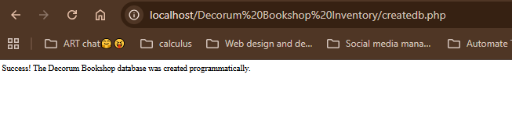
Figure 0-3: Database Connection Test

Error experienced during connection test. The webpage is not connected to the database. The PDO point sout the exact cause of the error.
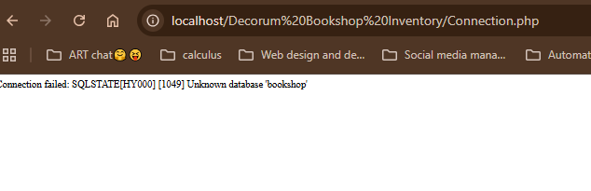
Figure 0-4: Error experienced during connection test.

REFLECTION
Fig 0-2 shows the MySQL can run on the computer as the local host. Fig 0-4 shows connection of the database to PHP sing PDO(PHP for Data Objects). PDO allows change of databases with minimal code change, meaning I can change to PostgresSQL or any other easily as compared to using mysqli-connect. This is more rigid as it serves MySQL and change would require changing the entire code. Using
$conn->setAttribute(PDO::ATTR_ERRMODE, PDO::ERRMODE_EXCEPTION);
prompts PDO to point out the exact case of error if the try block fails as seen in Fig 0-4
I’ve also learnt that a database can be created via PHP (Code below). The output is as seen in Fg0-3s
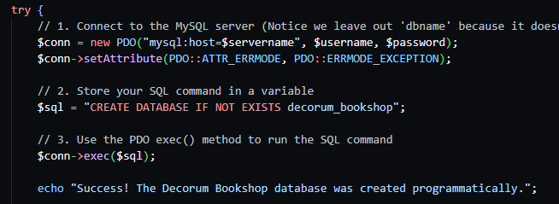
pFigure 0-5:PHP script for creating decorum_bookshop

Week 2: Wireframes and GUI Design

Title: User Interface Planning and System Design
- Hand-drawn Wireframe
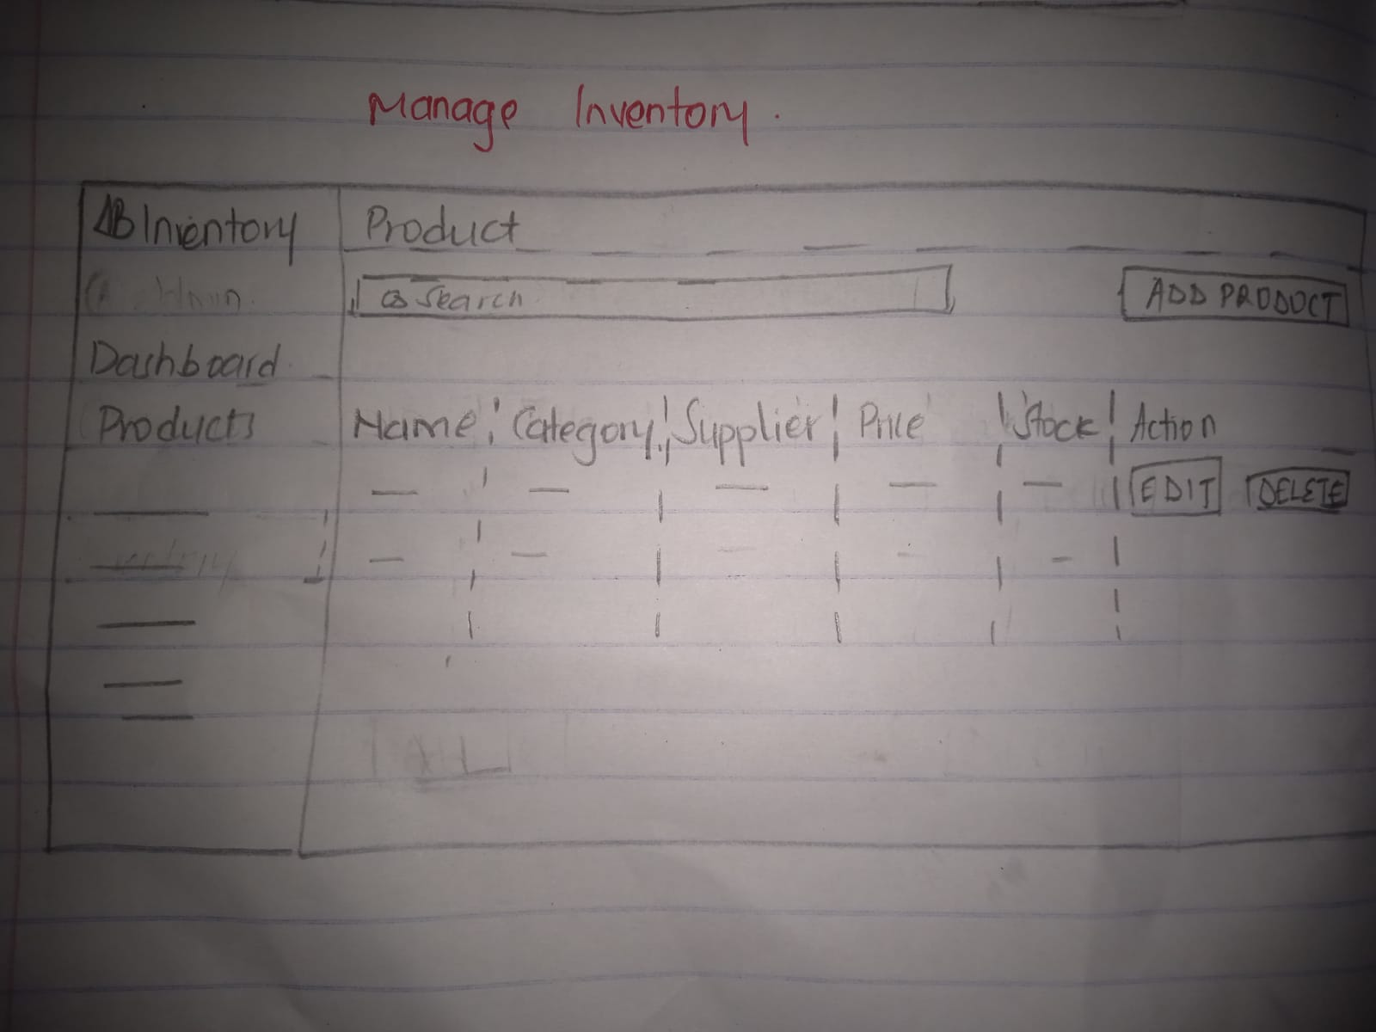
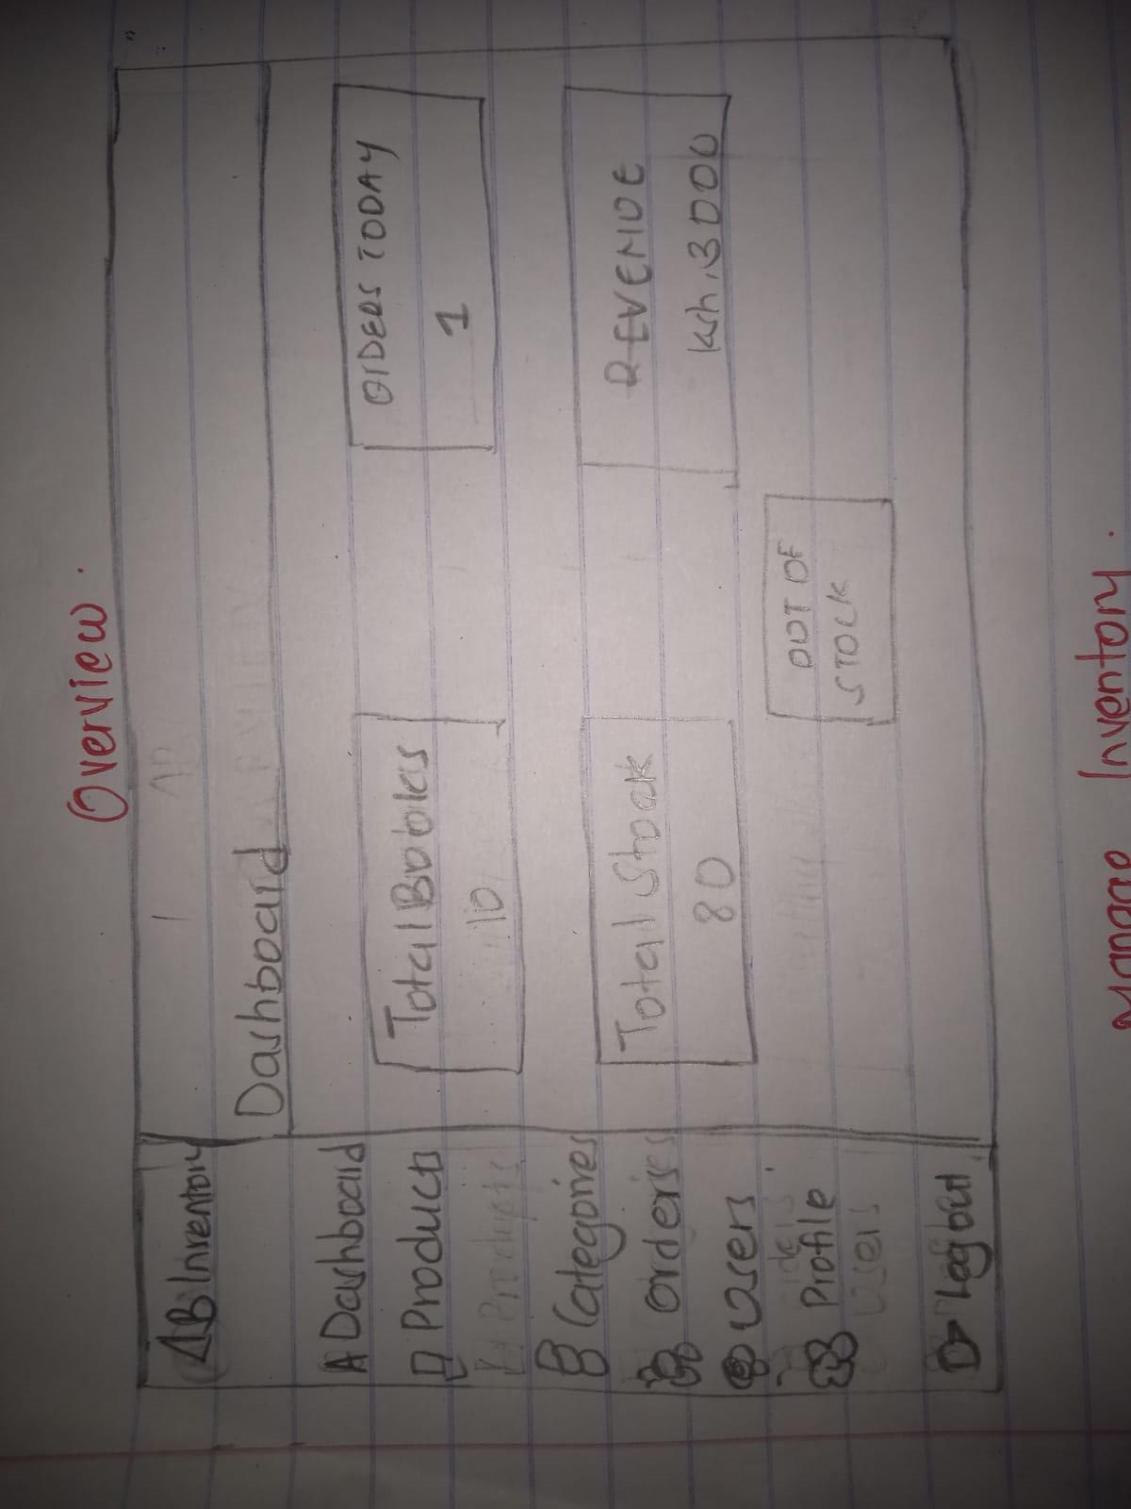Figure 0-1: Admin Product View
Admin Dashboard

Fig 2: Dashboard Layout Design
Figure 0-2:Admin Dashboard

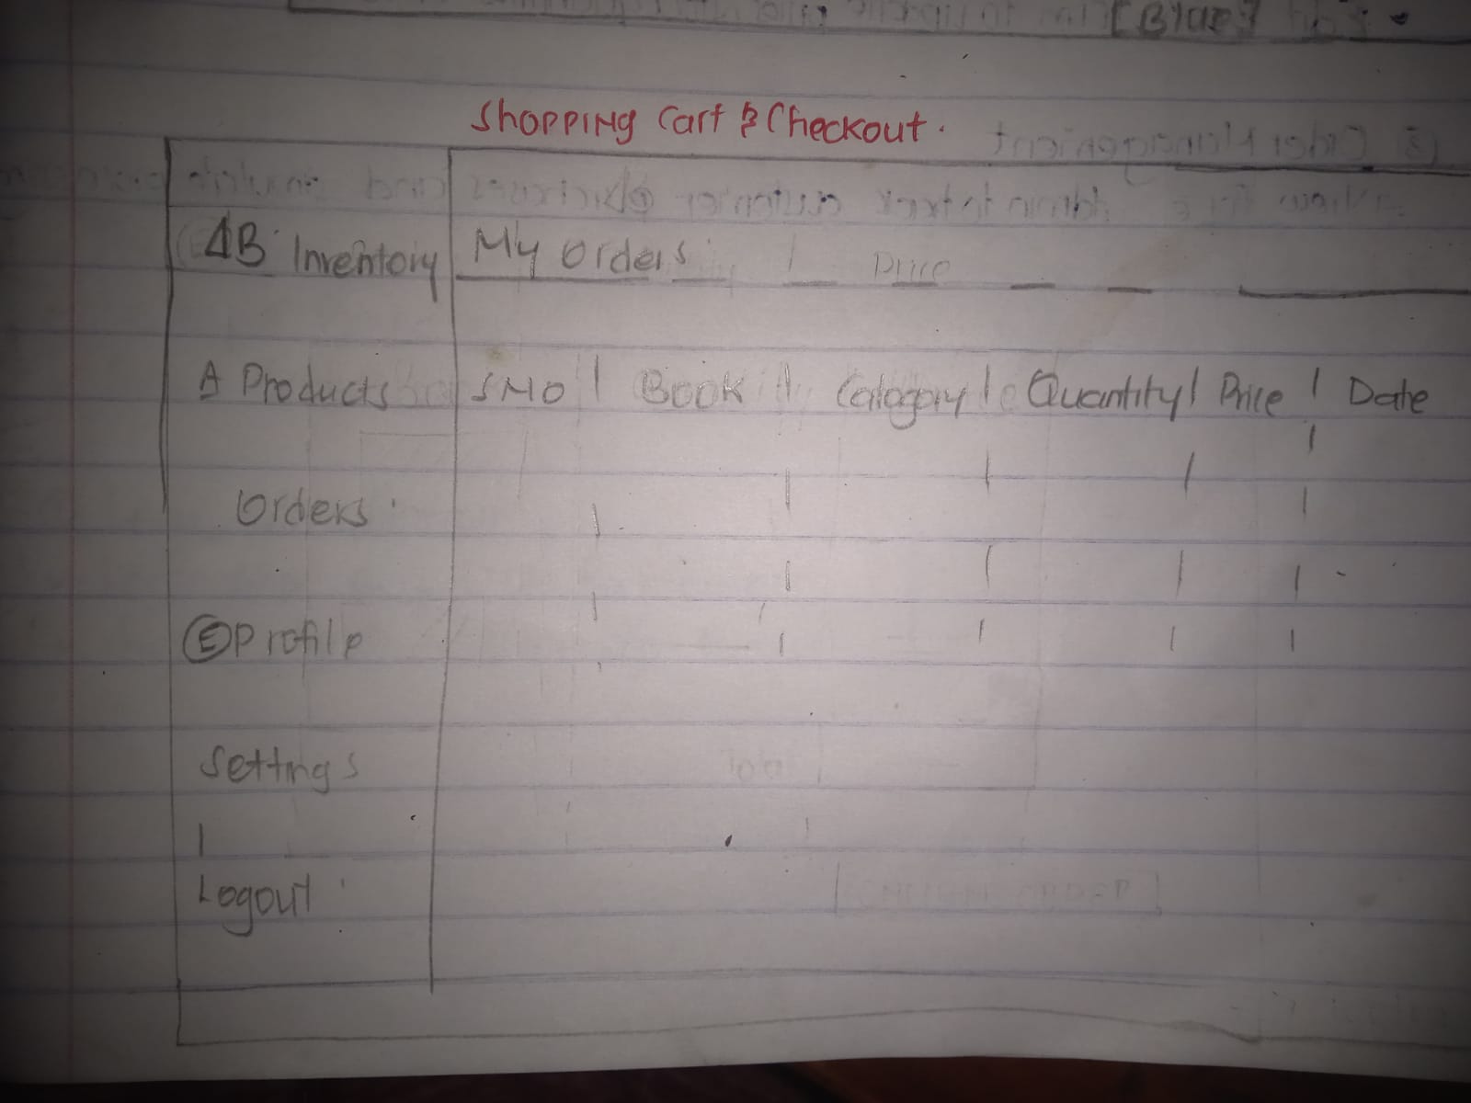
Figure 0-3:Users Order View
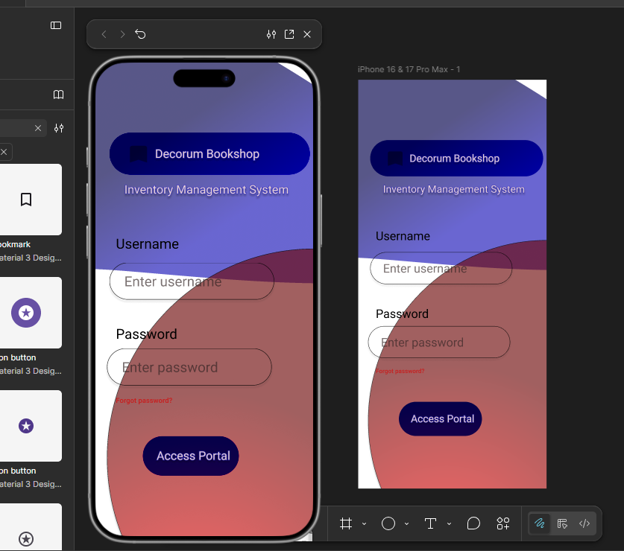
Figure 0-4:Login Page Design process
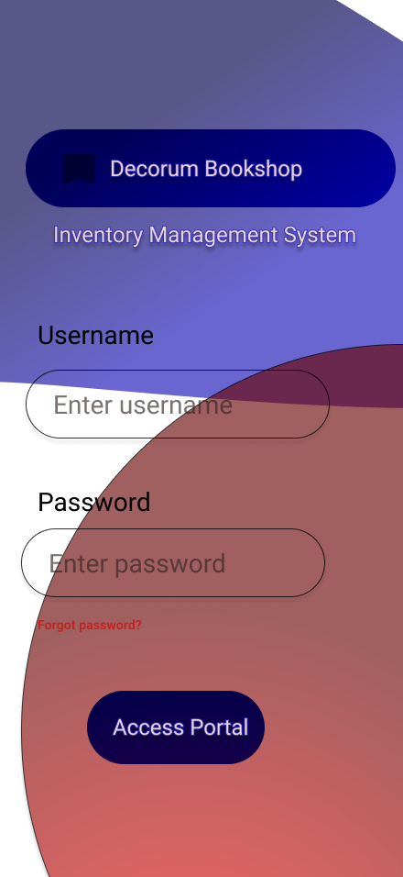
Figure 0-5:Login Page Figma Design
- COLOR THEME
- Red
- Blue
- White
- PROJECT THEME
Inventory System – Decorum Bookshop Inventory System.
Allows Admin manager to keep track of the books and records. The admin admits and tracks users within the system.
It is a Buyer to Buyer system (B2B)

REFLECTION
Creating the UI/UX components was challenging. I was able to hand draw but was challenged using Figma . Used a sidebar on the left because it is easy to hide and provide a simple, easy too. Use of Red, Blue and White color for their simplicity and easy communication. The dashboard itself remains static as content on it changes depending who has logged in(Admin/Manager). I’ve experienced multiple errors while translating the Figma design to code,currently working with a mockup.

Week 3: JavaScript and PHP Basics

Title:Frontend Interaction and Backend Foundation

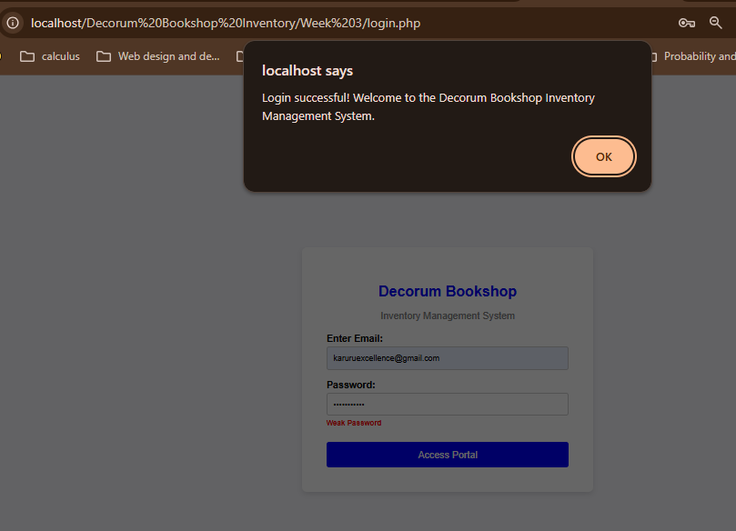
Figure 0-1:JavaScript Form Validation
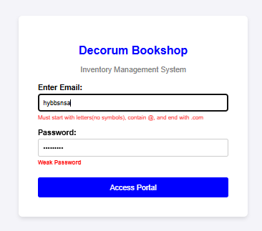

Figure 0-2:Email & Password validation.
Email Validation. Invalid email evokes an error message that prompts the user to enter the correct email format.

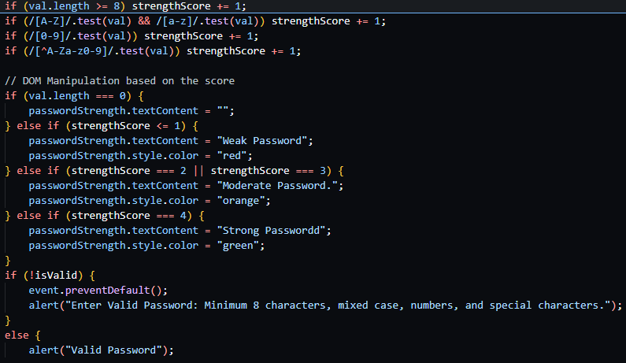
Figure 0-3:Password checker code

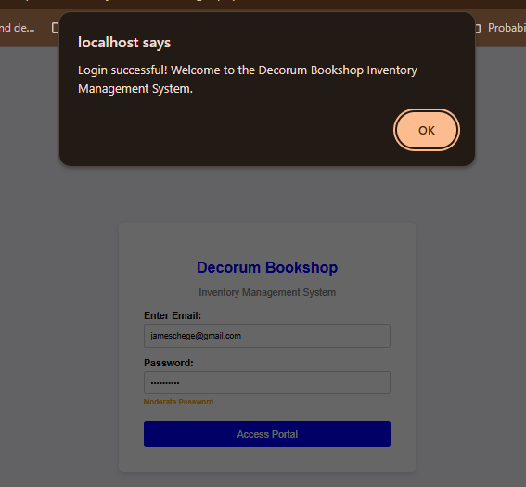
Figure 0-4:Successful login

Once user enters a Valid email & Password, they receive a SUCCESSFUL LOGIN message.
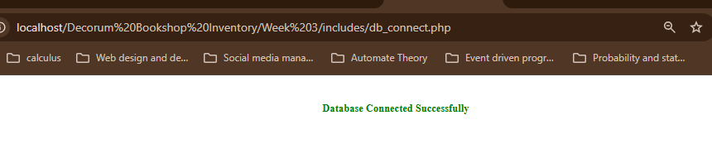
Figure 0-5:Successful Database Connection

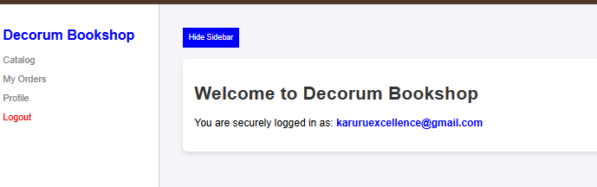
Figure 0-6: Successful login Into Decorum Bookshop
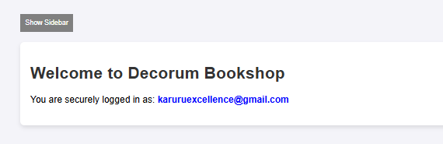
Figure 0-7: Hidden Sidebar
Document Object Model (DOM) is Achieved via Interactive Show/Hide Sidebar Button. It either Hides the sidebar when clicked and vice versa.

REFLECTION
Used PDO PHP with javascript and HTML. Implemented Password & Email validation using Java script. Learnt about Document Object Model and how to implement it. The Show/Hide SideBar Button changes the content of the page dynamically. Pushed the entire week 3 on Github for version Control and tracking changes.Encountered a few issues while committing Week 3 work but it was resolved. Commiting changes on

Week 4 Lesson: Server-Side Components and Backend Development Foundations

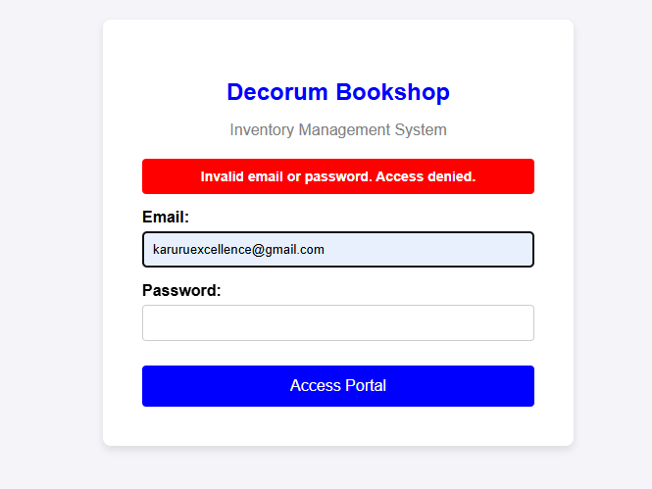
Figure 0-1:Server-Side authentication Handling
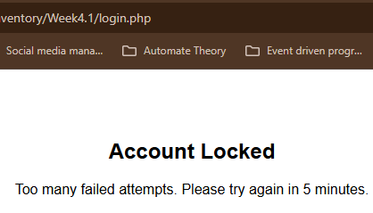
Figure 0-2:Account Bloced after 5 failed attempts
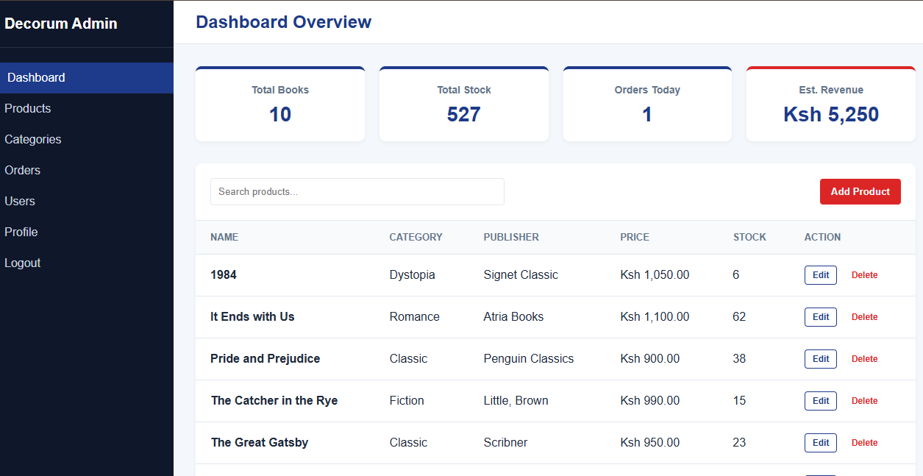
Figure 0-3RBAC- Administrator Dashboard
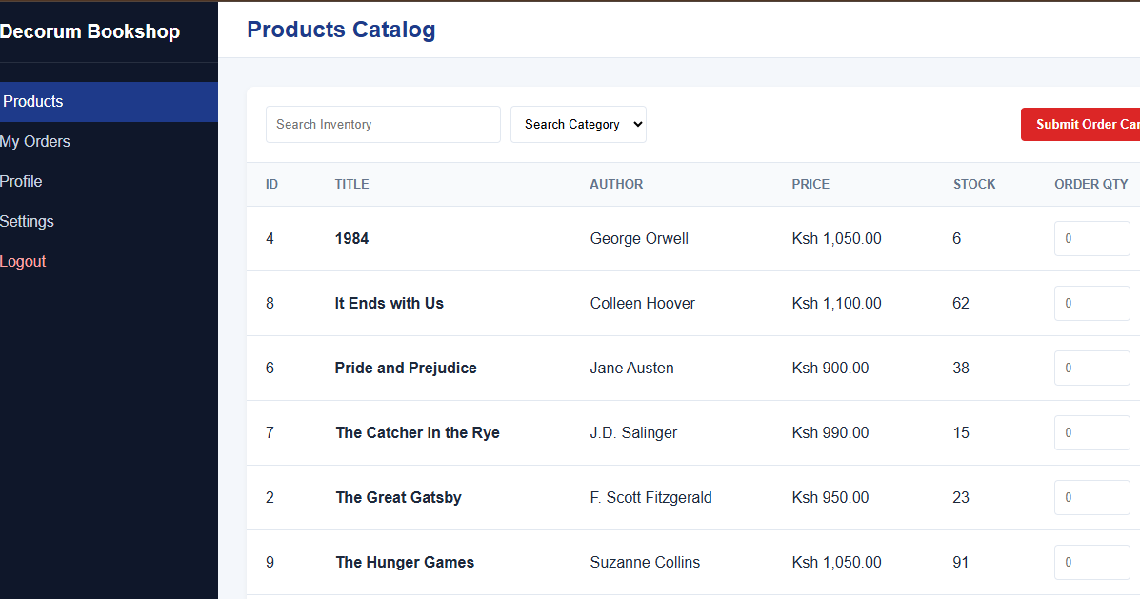
Figure 0-4: The Managers view.

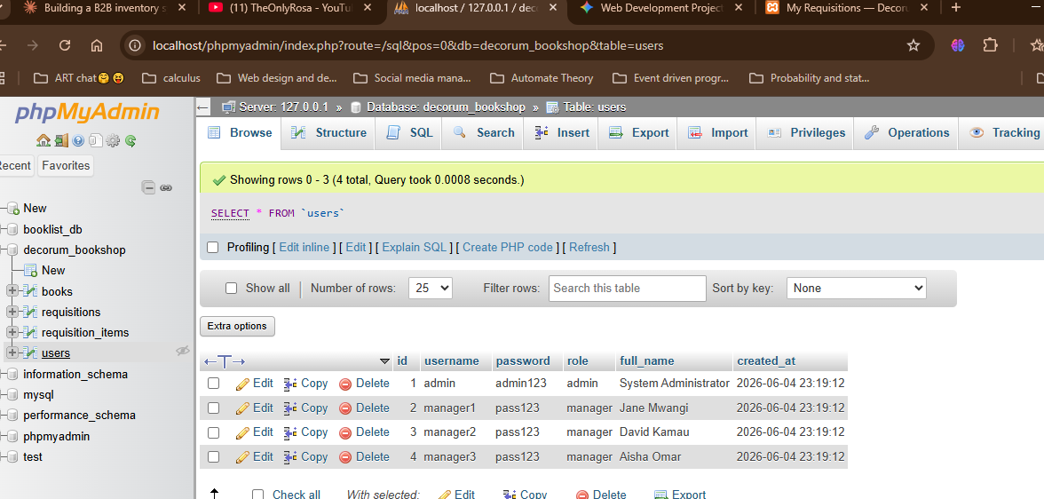
Figure 0-5: Backened Database schema- Users Table
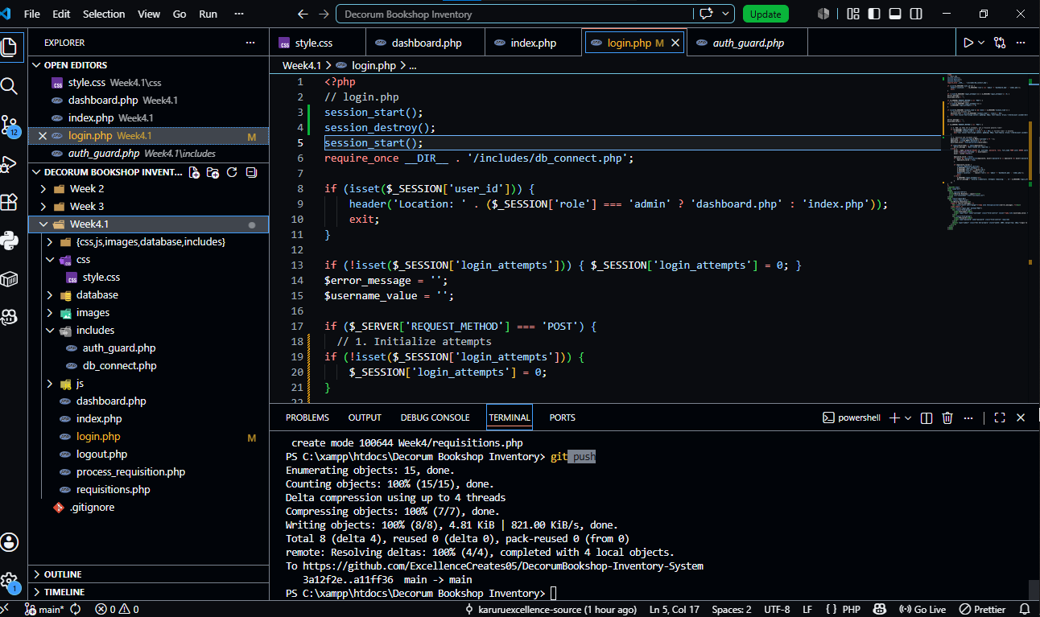
Figure 0-6: Backend Folder Structure

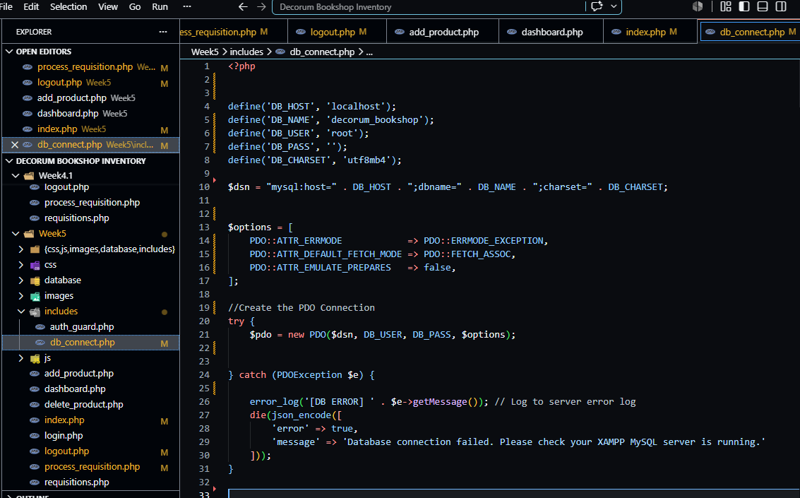
Figure 0-7: Dtabase Connection Script

REFLECTION

In this week I gained more knowledge on PHP for Data Objects centered Queries and code. It made it easy to work with clean prepared statements, making the platform more secure with less effort . I’ve learnt that it is Database agnostic , yet to prove but may test the feature in the future. Worked with a try-catch block in db_connect.php to connect to the database. It is well suited to handle exceptions that If…Else statement.

WEEK 5

TOPIC: Database Components and CRUD Operations

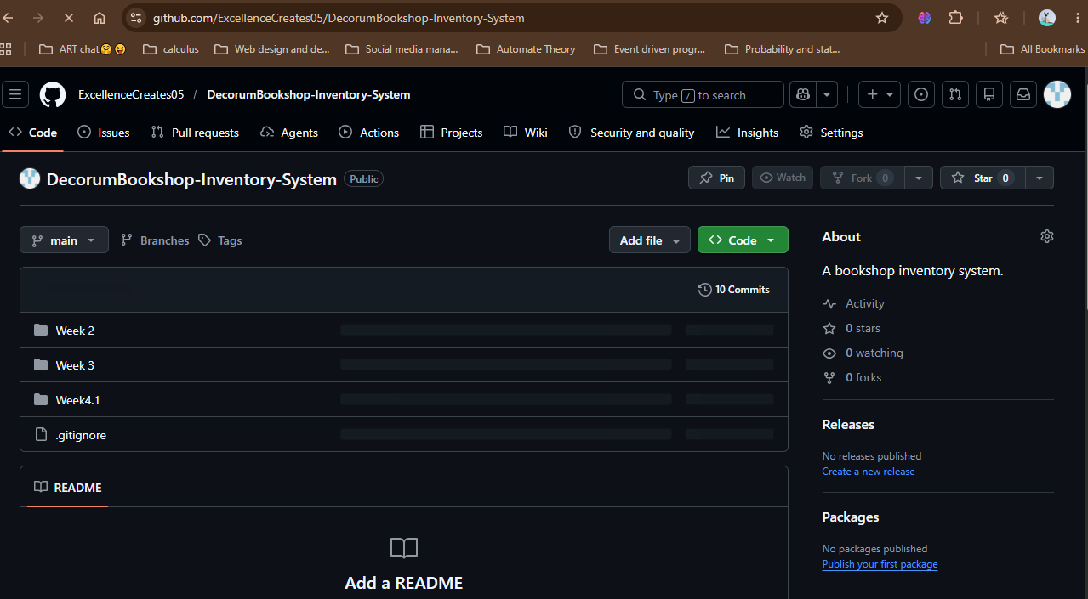
Figure 0-1:GitHub repository

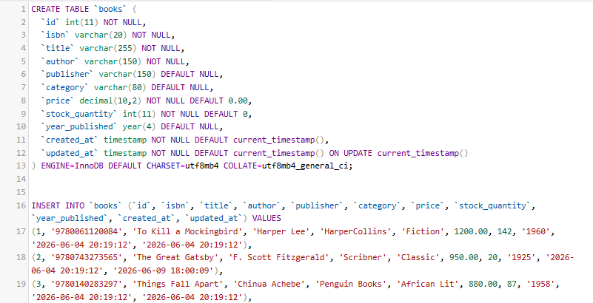
Figure 0-2:SQL Script CREATE Books Table and Insert sample book records
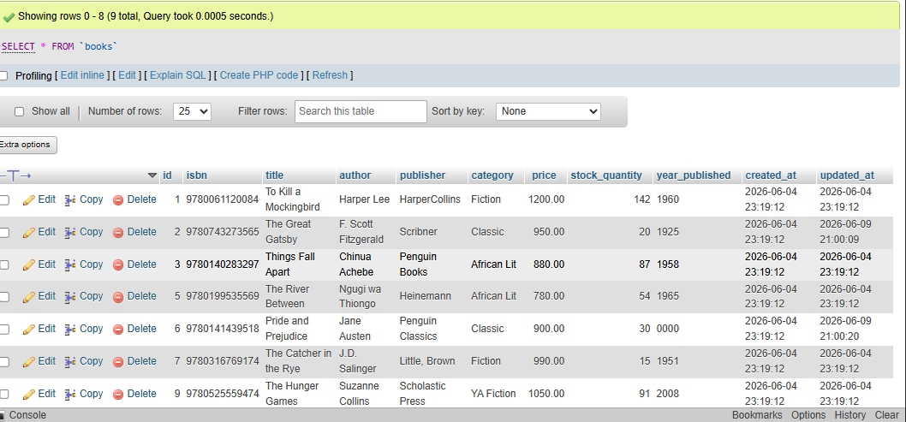
Figure 0-3: Books Table with Sample book records

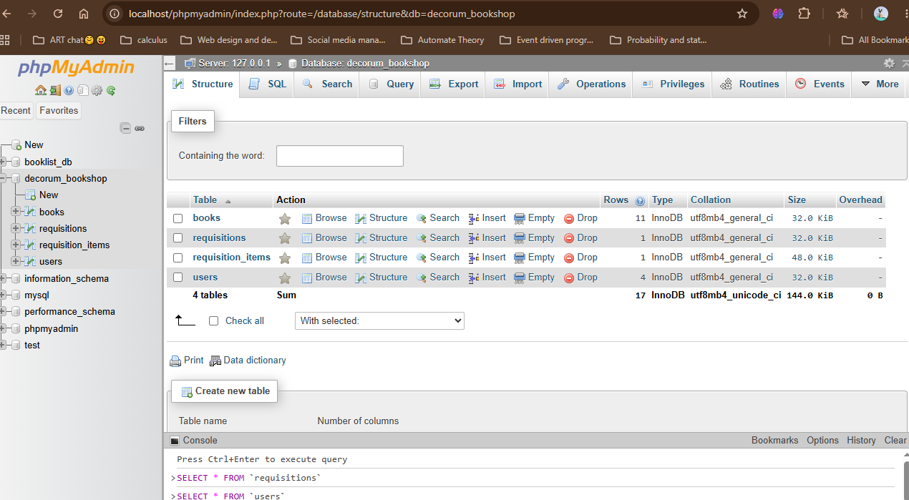
Figure 0-4: decorum_bookshop databse structure

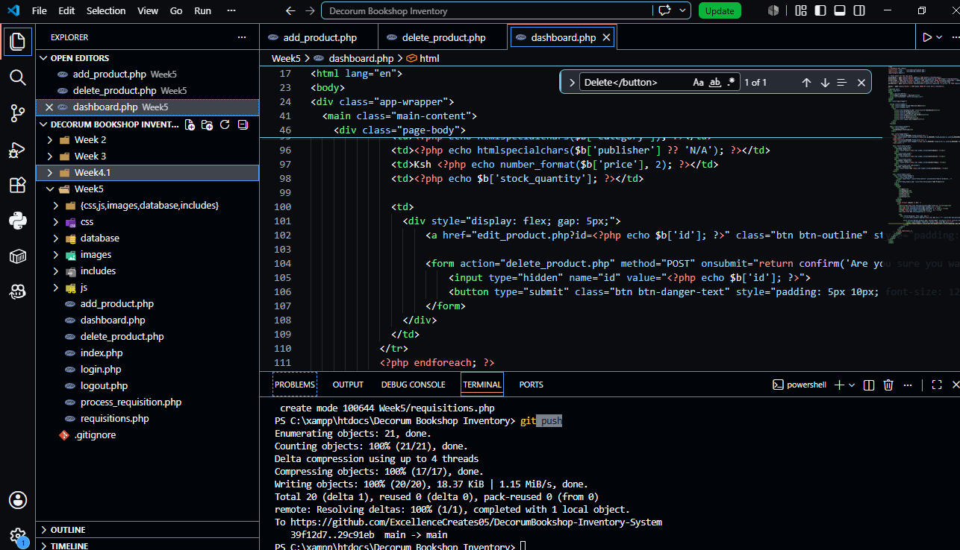
Figure 0-5: Week 5 File structure
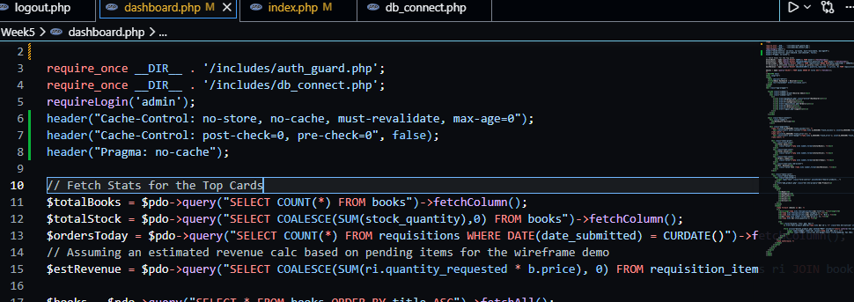
Figure 0-6:PDO Queries to fetch Order Mnagement Informtion from Database for the Top Cards

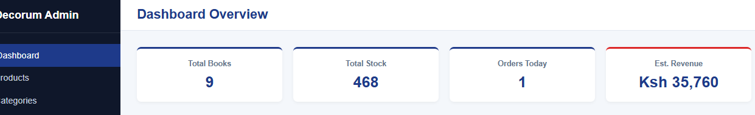
Figure 0-7; Top Cards
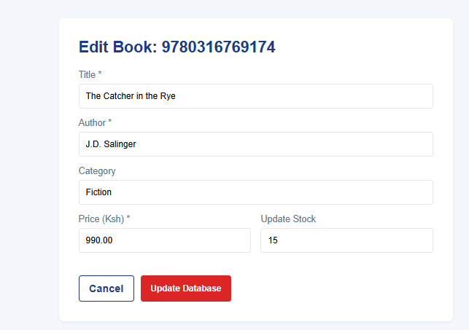
Figure 0-8:Edit Book records Form

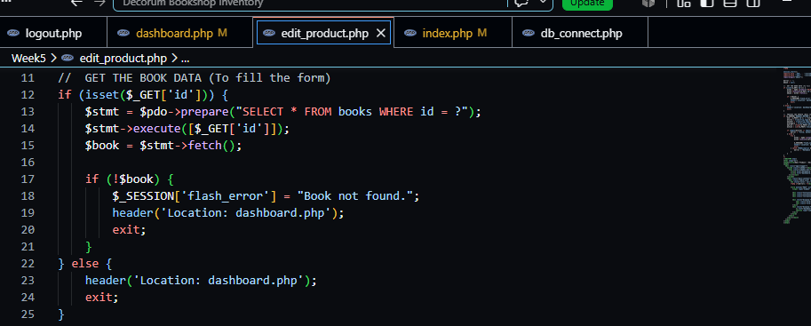
Figure 0-9: edit_product.php script lines that fetches the Book record to fill the edit Form.
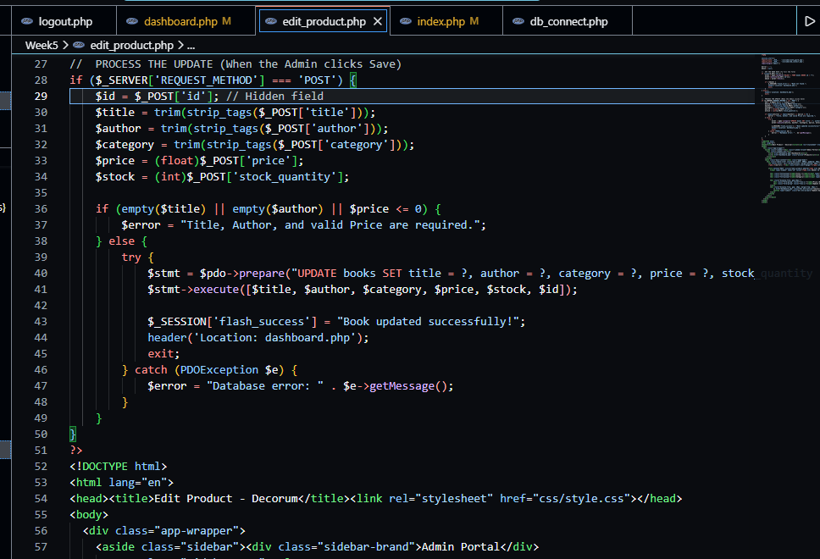
Figure 0-10: edit_record.php ; UPDATE records prepared statements.
Figure 0-11; Flash message showing Successful Update

REFLECTION
Fig 0_7 shows the prepared statement (line 13-15) that selects the records from the database reflects them in the Edit Form . The UPDATE Books..prepared statement(line40-49) send the updated records back to the database and ensures it reflects in the Product List

WEEK 6

Database Integration and CRUD Operations
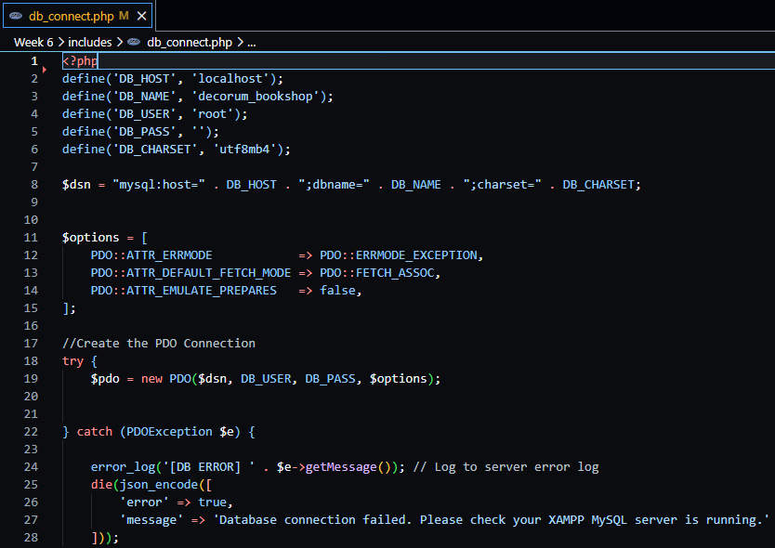
Figure 0-1:Database Connection Script
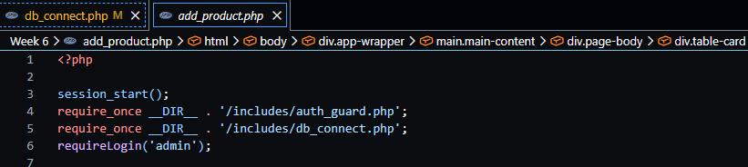
Figure 0-2: Connection script file inclusion
Modularization- Seperated the database connection into its own dedicated file creating a Module that is pulled into the other pages(File Inclusion) using the require_once__DIR__ method
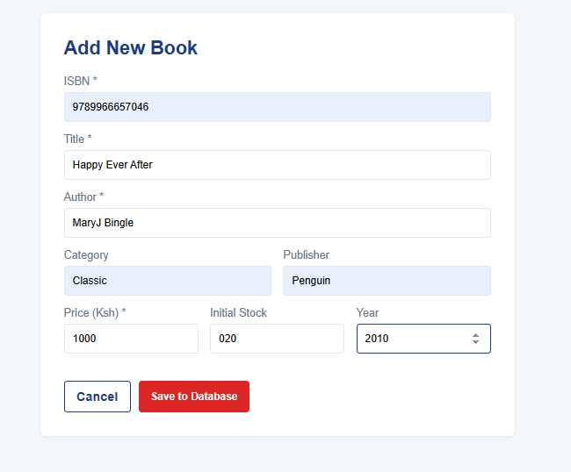
Figure 0-3: AddNew Book Form
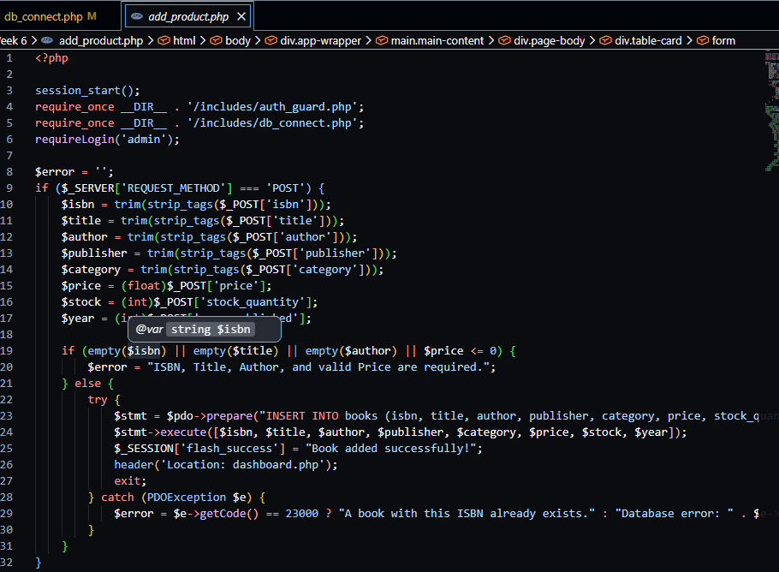
Figure 0-4;AddBook FormPHP script(add_product.php)
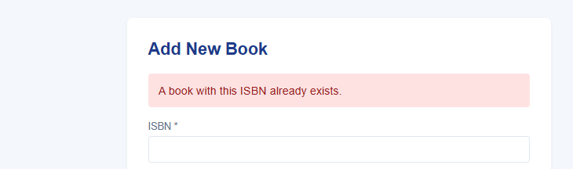
Figure 0-5; Error Message when a saved ISBN(Book unique identifier) is enetered
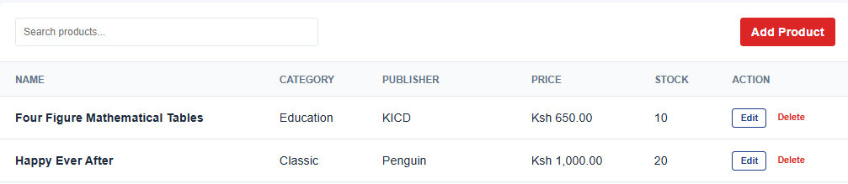Figure 0-6: New Book Record added(Happy Ever After), after using an usaved ISBN
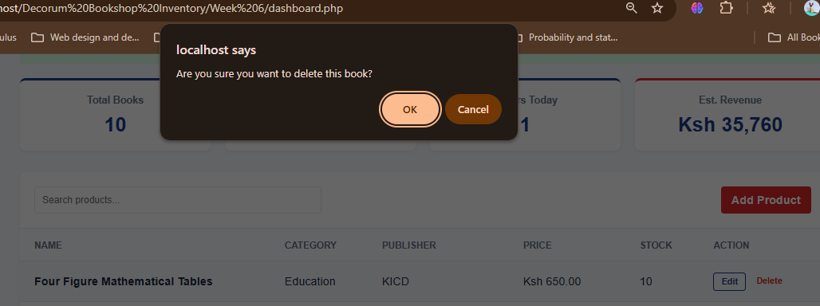
Figure 0-7:Delete Button flash message

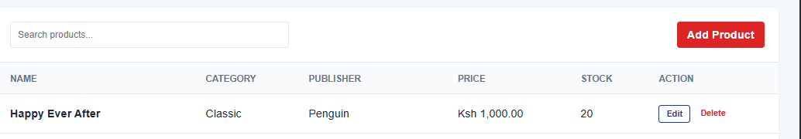
Figure 0-8;Deleted record(Four Figure Mathematical Tables)

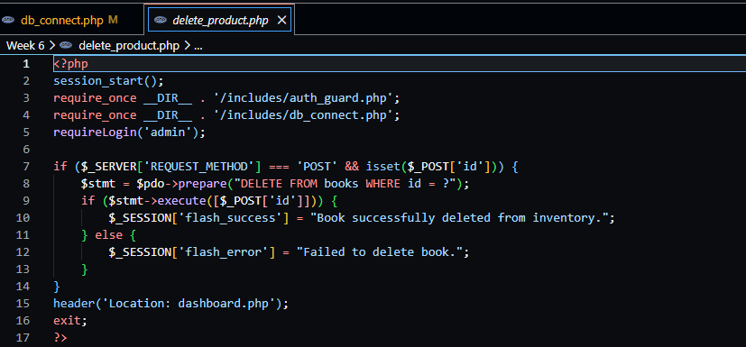
Figure 0-9:Delete_product script
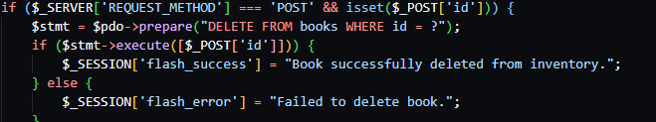
Use of prepared statement ($stmt = $pdo->prepare("DELETE FROM books WHERE id = ?") that provides a place holder for the book data . The if ($stmt->execute([$_POST['id']])….line binds the prepared statement to the actual book details and executes it sing METHOD=POST. This tells the databse to delete the record.

REFLECTION

WEEK 7

User Authentication and Session Management
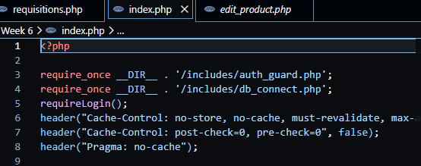
Screenshot to show To use The Manager Index.php page, it requires Log in, Managerial credentials.
The Header (Cache-Control), is HTTP that instructs the browser not to Cache the page. To always validate the page, every time a user log is

